Week 1 Assignment: SRS Document Development and GitHub

Nkosinomusa Gwalla
CST499: Capstone for Computer Software Technology
Professor Joseph Rangitsch
March 26, 2025

NOTE: This template is shareware downloaded from www.processimpact.com. All shareware payments are donated to the Norm Kerth Benefit Fund to help a consultant who is disabled with a brain injury. Please visit http://www.processimpact.com/norm_kerth.html to make a shareware payment ($10 suggested). Thank you!
Software Requirements Specification
for
Online Course Enrollment System
Version 1.0 approved
Prepared by Nkosinomusa Gwalla JR
University Of Arizona Global Campus
March 23, 2025
eLearning versions of several popular Process Impact training seminars are available at www.processimpact.com/elearning.shtml, including “In Search of Excellent Requirements,” “Exploring User Requirements with Use Cases,” “Writing High-Quality Requirements,” “Software Inspections and Peer Reviews,” and “Project Management Best Practices”. Single-user and corporate-wide site licenses are both available.
Table of Contents
Table of Contents ii
Revision History ii
1. Introduction 1
1.1 Purpose 1
1.2 Document Conventions 1
1.3 Intended Audience and Reading Suggestions 1
1.4 Project Scope 1
1.5 References 2
2. Overall Description 2
2.1 Product Perspective 2
2.2 Product Features 2
2.3 User Classes and Characteristics 3
2.4 Operating Environment 3
2.5 Design and Implementation Constraints 4
2.6 User Documentation 4
2.7 Assumptions and Dependencies 5
3. System Features 5
3.1 User Registration and Profile Creation 5
3.2 Login and Authentication 6
3.3 Course Enrollment and Waitlist Management 6
3.4 Course Catalog Management 6
3.5 Enrollment Cancellation Process 7
4. External Interface Requirements 7
4.1 User Interfaces 7
4.2 Hardware Interfaces 8
4.3 Software Interfaces 8
4.4 Communications Interfaces 8
5. Other Nonfunctional Requirements 9
5.1 Performance Requirements 9
5.2 Safety Requirements 9
5.3 Security Requirements 9
5.4 Software Quality Attributes 9
6. Other Requirements 10
Appendix A: Glossary 10
Appendix B: Analysis Models 11
Diagram 1: Data Flow Diagram for the User Registration Process 11
Appendix C: Issues List 12

Revision History
Name | Date | Reason For Changes | Version
 |  | Initial creation based on assignment requirements | 1.0

Introduction

Purpose
The Online Course Enrollment System needs software specifications that are documented in this document. The system functions to enable student enrollment along with class selection and course waiting procedures for digital courses administered during three academic periods (spring, summer, and fall). Enrollment features of the system consist of secure account management alongside authentication and enrollment with capacity limits and waitlist management functions and notification systems for enrollment cancellation requests. The SRS presents essentials for Version 1.0 functionality which makes up the initial part of an extended software development lifecycle project.

Document Conventions
Standards: This document follows IEEE guidelines for software requirements documentation.
Priority Indicators: Requirement priorities are classified as High, Medium, or Low.
Placeholders: “TBD” is used for items where detailed information is pending.

Intended Audience and Reading Suggestions
This SRS is intended for:
- Developers who will implement the system functionalities.
- Project Managers and Testers who require a clear understanding of system capabilities and constraints.
- Stakeholders (e.g., course administrators and IT staff) interested in the overall design and business objectives.
Readers are advised to start with the Overview sections (Sections 1 and 2) before reviewing detailed system features in Section 3.

Project Scope
The Online Course Enrollment System will streamline student registration and course enrollment. Key functionalities include:
- User Registration: Unique user ID creation, password setup, and profile details input (name, phone, email, etc.).
- Authentication: Secure login process for registered users.
- Course Enrollment: Display of course offerings by semester, enforcement of enrollment limits, and waitlist capabilities.
- Cancellation and Notification: Ability to cancel enrollment with automatic notification sent to the first waitlisted student.
This system is envisioned as a key component of the institution’s broader digital transformation in course management.

References
IEEE Computer Society. (1998). IEEE Recommended Practice for Software Requirements Specifications (IEEE Std 830-1998). IEEE. https://standards.ieee.org/standard/830-1998.html

Wiegers, K. E., & Beatty, J. (2013). Software Requirements (3rd ed.). Microsoft Press. https://www.microsoftpressstore.com/store/software-requirements-9780735679665

Overall Description

Product Perspective
The brand-new Online Course Enrollment System functions as a standalone web-based application which modernizes and automates the processes of student registration and enrollment and waitlist administration. The system both automates outdated methods and creates connections with student information systems as well as email services to deliver proper data maintenance and smooth digital interactions. The system diagram shows how the major components connect through their interconnections while the external communication interfaces are represented:
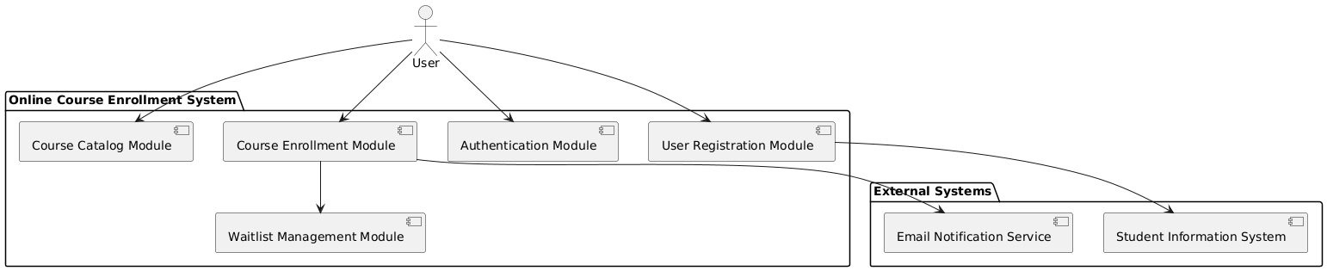

Product Features
At a high level, the system supports several key features:
- User Registration & Profile Management: Enables students to create unique accounts and store personal details (name, phone, email).
- Secure Authentication: Provides a robust login mechanism with encryption and account lockout for failed attempts.
- Course Enrollment: Displays available courses by semester, enforces enrollment limits, and manages waitlists if courses are full.
- Enrollment Cancellation & Notification: Allows students to cancel enrollments and automatically notifies the next student on the waitlist.
- Course Catalog Management: Offers an organized view of course details including descriptions, schedules, and capacity limits.
Below is a high-level class diagram representing the main entities and relationships:

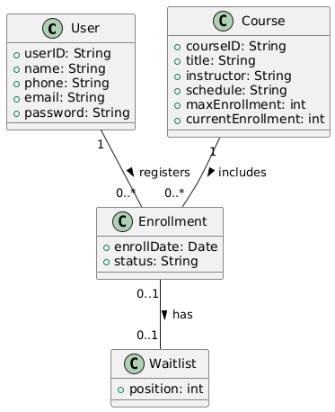

User Classes and Characteristics
The system caters to several distinct user classes:
Students:
  - Primary users who enroll in courses.
  - Familiar with basic web interfaces and require straightforward access to course details and enrollment options.
Administrators:
  - Manage course offerings, update enrollment limits, and maintain overall system integrity.
  - Typically have advanced technical expertise and higher security privileges.
Support Staff:
  - Provide assistance to students and administrators by resolving technical issues and guiding system usage.
  - Their role focuses on user support rather than direct system management.
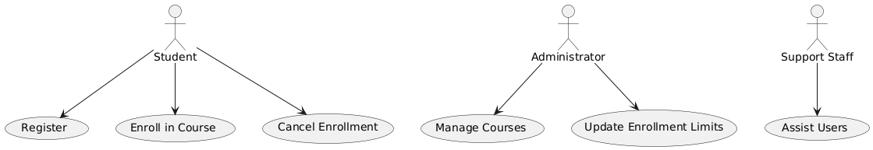
The following use-case diagram visualizes the interactions of these user classes with the system:

Operating Environment
The system is designed to operate in a modern, web-based environment. Key characteristics include:
- Platform: Accessible via standard web browsers (Chrome, Firefox, Edge) on desktop and mobile devices.
- Server Environment: Hosted on web servers with a backend relational database (e.g., MySQL or PostgreSQL) to store user and course data.
- Integration: Capable of interfacing with external systems, such as the Student Information System for data synchronization and an Email Notification Service for communication.
A deployment diagram that outlines the operating environment is provided below:
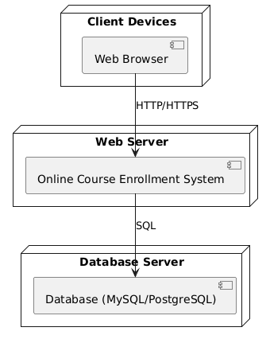

Design and Implementation Constraints
The development of the system is subject to several constraints, including:
- Compliance: Must adhere to institutional IT policies and applicable data privacy regulations.
- Integration: Requires seamless integration with the existing Student Information System and third-party email services.
- Technology: Utilizes Git for version control and hosts the repository on GitHub.
- Performance: Designed to handle concurrent user sessions with a fast response time under load.
The diagram below highlights the system along with key constraints and integration points:
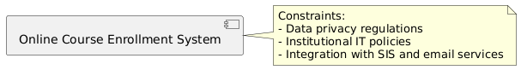

User Documentation
User documentation will be delivered in multiple formats to assist all user classes in effectively using the system. Documentation components include:
- User Manual: A comprehensive guide for students and administrators.
- Online Help: Context-sensitive help features embedded within the application.
- Tutorials and FAQs: Step-by-step tutorials and frequently asked questions to support quick-start and troubleshooting.

Assumptions and Dependencies
The system’s requirements are based on the following assumptions and dependencies:
- Assumptions:
  - Users have reliable internet access and modern web browsers.
  - Accurate course data will be provided by academic departments.
- Dependencies:
  - Integration with a Student Information System for student records.
  - Third-party email services for sending notifications.
The diagram below outlines these assumptions and dependencies:

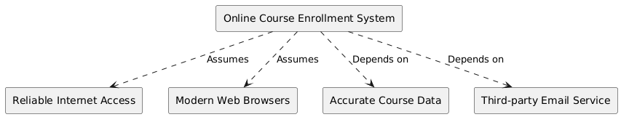

System Features
This section organizes the functional requirements for the Online Course Enrollment System into distinct system features. Each feature is described by its purpose, priority, the sequence of user actions and system responses, and the detailed functional requirements.

User Registration and Profile Creation
3.1.1 Description and Priority
This high-priority capability enables fresh users to establish their account through the provision of a distinctive user ID along with necessary personal information that includes name and phone number and email. The registration step serves as a necessary beginning that lets users access every system capability.
3.1.2 Stimulus/Response Sequences
Stimulus: A new user navigates to the registration page and enters the required information.
Response: The system verifies that the chosen user ID is unique, creates a new account, and confirms the registration with an on-screen message as well as an email notification.
3.1.3 Functional Requirements
REQ-1: The system shall enforce uniqueness of the user ID during registration.
REQ-2: The system shall capture and securely store user profile details, including name, phone number, and email address.
REQ-3: The system shall display a confirmation message and send an email notification upon successful registration.

Login and Authentication
3.2.1 Description and Priority
The high-priority feature allows registered users to access the system securely through login with their credentials. This feature utilizes two essential security functions which consist of password encryption processes and account locking during consecutive failed access attempts.
3.2.2 Stimulus/Response Sequences
Stimulus: A user enters their user ID and password on the login page.
Response: The system validates the credentials. If the credentials are correct, the user is granted access to the main dashboard; otherwise, an error message is displayed.
3.2.3 Functional Requirements
REQ-4: The system shall validate user credentials against stored records.
REQ-5: The system shall implement password encryption and automatically lock out accounts after a specified number of failed login attempts.

Course Enrollment and Waitlist Management
3.3.1 Description and Priority
Process management for course enrollment stands among top features. Students can select available courses through the enrollment system before the course fills up and they can enter a waiting position for full seats.
3.3.2 Stimulus/Response Sequences
Stimulus: A student selects a course for enrollment.
Response: The system checks the enrollment count. If the course is not full, the student is enrolled; if full, the student is offered the option to join the waitlist.
3.3.3 Functional Requirements
REQ-6: The system shall display each course's maximum capacity and current enrollment count.
REQ-7: The system shall allow a student to join the waitlist if a course has reached its maximum enrollment.
REQ-8: The system shall automatically notify the first student on the waitlist when a spot becomes available due to an enrollment cancellation.

Course Catalog Management
3.4.1 Description and Priority
This medium-priority feature provides a comprehensive view of the course offerings by semester. It helps both students and administrators by displaying course details such as descriptions, schedules, and enrollment limits.
3.4.2 Stimulus/Response Sequences
Stimulus: A user accesses the course catalog page.
Response: The system retrieves and displays a list of courses filtered by semester and other criteria as applicable.
3.4.3 Functional Requirements
REQ-9: The system shall allow filtering of courses by semester (e.g., spring, summer, fall).
REQ-10: The system shall display detailed course information, including course title, instructor, schedule, and maximum enrollment capacity.

Enrollment Cancellation Process
3.5.1 Description and Priority
This high-priority feature allows students to cancel their course enrollments. Once a cancellation occurs, the system updates the enrollment count and notifies the next student on the waitlist, ensuring that open slots are promptly filled.
3.5.2 Stimulus/Response Sequences
Stimulus: A student initiates a course enrollment cancellation from their account.
Response: The system processes the cancellation, updates the course's enrollment count, and triggers a notification to the first student on the waitlist.
3.5.3 Functional Requirements
REQ-11: The system shall allow students to cancel their course enrollments through their account interface.
REQ-12: The system shall update the course's enrollment count immediately after a cancellation is processed.
REQ-13: The system shall notify the first student on the waitlist when a cancellation creates an available slot.

External Interface Requirements

User Interfaces
The Online Course Enrollment System is designed with a responsive, web-based user interface that adapts seamlessly across desktops, tablets, and smartphones. Key characteristics include:
- Consistent Layout: Each screen (e.g., registration, login, course catalog, enrollment, and cancellation) follows a consistent design with a common header, navigation menu, and footer.
- Accessibility: Interfaces adhere to accessibility guidelines (e.g., WCAG) ensuring users with disabilities can navigate and interact with the system.
- Standard Elements: Each page includes standard buttons (Submit, Cancel, Help), clearly visible error messages, and keyboard shortcuts where applicable.
- Visual Design: The design aligns with the institution’s branding guidelines, ensuring clear typography, intuitive icons, and color contrasts that enhance usability.
- Help and Tutorials: On-screen help icons and context-sensitive tooltips assist users in navigating the system, while a dedicated help section and FAQs are accessible via the main menu.
A separate User Interface Specification document details screen mock-ups, wireframes, and layout constraints.

Hardware Interfaces
The system operates primarily as a web-based application and does not require specialized hardware. However, it must support the following hardware conditions:
- Supported Devices: Compatible with standard desktops, laptops, tablets, and smartphones.
- Input/Output Devices: Designed to work with common peripheral devices such as keyboards, mice, and touchscreens.
- Communication Protocols: Interfaces with hardware (e.g., network cards) via standard protocols such as TCP/IP to support HTTP/HTTPS communications.
No additional physical hardware interfaces are required beyond ensuring compatibility with widely available consumer devices.

Software Interfaces
The system integrates with several external software components to support its core functionalities:
- Database Management: Utilizes a relational database (e.g., MySQL or PostgreSQL) for storing user profiles, course details, enrollments, and waitlist data.
- Student Information System (SIS): Interfaces with the institution’s existing SIS to retrieve and update student records. The integration follows RESTful API standards with JSON payloads for data exchange.
- Email Notification Service: Uses third-party email services (e.g., SendGrid or SMTP-based solutions) to dispatch registration confirmations, enrollment updates, and waitlist notifications.
- Authentication Libraries: Employs standard cryptographic libraries (e.g., bcrypt) for password encryption and secure credential validation.
All data exchanges between these software components are documented in the API Specification Document, outlining message formats, protocols, and authentication mechanisms.

Communications Interfaces
The system’s communication requirements focus on secure, reliable data exchange:
- Web Communication: Utilizes HTTP/HTTPS protocols to facilitate data transfer between client devices and the web server. Secure Sockets Layer (SSL)/Transport Layer Security (TLS) protocols are used to encrypt all communications.
- Email Communication: Outgoing notifications are sent via SMTP protocols with appropriate authentication and encryption to prevent interception.
- Data Synchronization: When interacting with the SIS or other integrated systems, the system uses RESTful APIs with standardized JSON message formatting.
- Network Protocols: Supports standard internet protocols, and is designed to operate effectively under typical network conditions, with fallbacks for slower connections.

Other Nonfunctional Requirements

Performance Requirements
The system is designed to provide a responsive and scalable user experience:
- Response Time: Critical operations (e.g., login, enrollment, and course catalog retrieval) should respond within 2 seconds under normal load.
- Concurrent Users: The system must support at least 500 concurrent users during peak enrollment periods without degradation in performance.
- Scalability: The architecture should be scalable to accommodate increases in user numbers and course offerings.
- Load Balancing: Implement load balancing strategies to distribute user requests evenly across servers, ensuring high availability and resilience.

Safety Requirements
Although the system does not directly interact with hazardous equipment, it incorporates safety measures to prevent data loss and ensure business continuity:
- Data Backup: Regular backups of the database must be performed, with offsite storage options for disaster recovery.
- Failover Mechanisms: The system should include failover procedures to minimize downtime in the event of server or network failures.
- Error Handling: Robust error detection and logging mechanisms must be in place to capture and address issues before they affect users.

Security Requirements
Security is paramount to protect sensitive student information and system integrity:
- Data Encryption: All sensitive data, including user credentials, must be encrypted both at rest and in transit using industry-standard encryption methods.
- Authentication: Implement secure authentication protocols with multi-factor authentication (MFA) options for enhanced security.
- Access Control: Enforce role-based access control (RBAC) to restrict system functionalities based on user roles (e.g., students, administrators, support staff).
- Vulnerability Management: Regular security audits, vulnerability scans, and penetration testing should be conducted to identify and mitigate potential security threats.
- Compliance: The system must comply with relevant data protection regulations such as FERPA or GDPR, as applicable.

Software Quality Attributes
The system should exhibit the following quality attributes to meet both user and developer expectations:
- Usability: Interfaces must be intuitive, with minimal learning curve, and designed according to established usability standards.
- Reliability: The system should maintain a high uptime (targeting 99.9% availability) and include error-recovery mechanisms.
- Maintainability: Code should be modular and well-documented to facilitate easy updates and debugging.
- Portability: The system should be platform-independent, accessible from any modern web browser, and easily deployable on various server environments.
- Interoperability: The architecture must support integration with external systems, such as the SIS and third-party email services, using standard protocols and data formats.
- Testability: The system should be designed to support automated testing frameworks, including unit tests, integration tests, and end-to-end tests.

Other Requirements
• Database Requirements:
A relational database management system (either MySQL or PostgreSQL) will serve as the storage method for user profiles as well as course details and enrollments and waitlists. The system requires simultaneous access management capabilities and transaction-based data validity systems alongside growth expansion potential.
• Internationalization Requirements:
Although the system’s initial release will be in English, it must be designed with internationalization in mind. This includes the ability to support multiple languages and cultural formats (such as date/time and currency), making it easier to localize for other regions in the future.
• Legal and Regulatory Requirements:
The system needs to fulfill every requirement of applicable legal along with regulatory standards including both Family Educational Rights and Privacy Act (FERPA) in the United States and General Data Protection Regulation (GDPR) for suitable territories. Users must grant their consent for data storage while the system needs to handle data correctly with secure policies for data preservation.
• Reuse Objectives:
The system architecture should promote modularity and reusability. Code should be developed using well-known design patterns (e.g., Model-View-Controller) and documented thoroughly to facilitate reuse in future projects or system enhancements.
• Other Considerations:
The solution needs to support future connections with additional third-party components including analytics solutions and external learning platforms and maintain protocols for effortless changes without major reconstruction efforts.

Appendix A: Glossary
User ID: A unique identifier assigned to each registered user.
SIS (Student Information System): A system that manages student records and academic information.
Waitlist: A queue of students waiting for a course slot when the enrollment capacity is reached.
Enrollment: The process by which a student registers for a course.
Authentication: The mechanism that verifies a user’s credentials to ensure secure access.
MVC (Model-View-Controller): A software architectural pattern used for developing user interfaces by dividing the application into three interconnected components.
Appendix B: Analysis Models
Diagram 1: Data Flow Diagram for the User Registration Process
This diagram illustrates the flow of information during the user registration process—from the user’s input through validation and storage in the database.
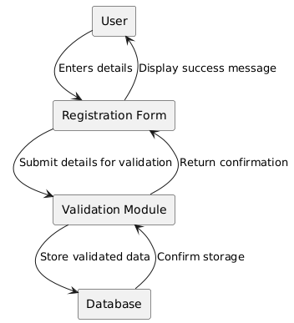

Diagram 2: State Transition Diagram for Course Enrollment Process
This state diagram models the process a student undergoes when enrolling in a course, including handling full courses via the waitlist and processing cancellations.

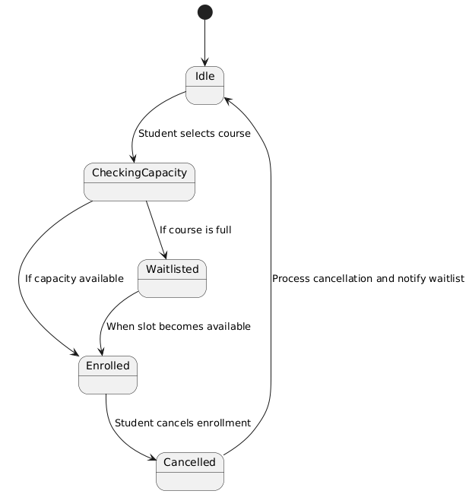

Diagram 3: Entity-Relationship Diagram for the Database Schema
This ER diagram depicts the core entities and their relationships in the database, including users, courses, enrollments, and waitlists.

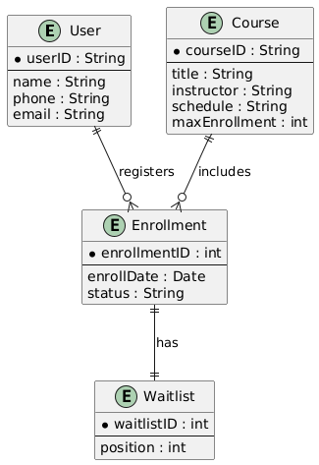
Appendix C: Issues List
The following is a dynamic list of open requirements issues that are pending resolution. This list should be updated throughout the project lifecycle.
Issue 1: SIS Integration API Details
  - Description: The specific API endpoints, data formats, and security requirements for integrating with the existing Student Information System have not been fully defined.
  - Priority: High
  - Status: TBD
Issue 2: Email Notification Formatting
  - Description: Detailed requirements for the content, layout, and timing of email notifications (registration confirmations, waitlist updates) need to be finalized.
  - Priority: Medium
  - Status: TBD
Issue 3: Internationalization Guidelines
  - Description: While the system is initially in English, requirements for future localization (e.g., additional languages and regional formats) need further clarification.
  - Priority: Medium
  - Status: TBD
Issue 4: Security Protocols Verification
  - Description: Verification of security protocols and compliance checks with current standards require further review by the IT security team.
  - Priority: High
  - Status: TBD

